Title of the Paper


1st Authors Name¹, 2nd Authors Name², 3rd Authors Name³
¹Affiliation of 1st author: (Department name of organization, City – Country).
²Affiliation of 2nd author: (Department name of organization, City – Country).
³Affiliation of 3rd author: (Department name of organization, City – Country).
¹e-mail of 1st author, ²e-mail of 2nd author, ³e-mail of 3rd author,
(Corresponding author email alone can suffice. Indicate with * as superscript).

Keywords: –  5 keywords to identify the major topics. Arrange the words in alphabetical order with each on a single line.  Article History: –  Received:  Reviewed:  Accepted:  Published: |  | ABSTRACT  This template contains the manuscript preparation guideline of Zaria Journal of Electrical Engineering Technology (ZJEET) updated in January 2019. ZJEET accepts and publishes articles in English language. The format of various components of the paper [title, text, headings, etc.] are already defined, as illustrated by the portions given in this document. The abstract is limited to 150 words and cannot contain equations, figures, tables, or references. It should concisely state the novelty, main findings and significant contribution of the work. The text of the abstract should be written fully justified, in single paragraph, presented, in italics, 11 point font size, 1.15 line spaced. Do not change the predefined margins, paper type and other layout of this document.
 |  |  | .

- INTRODUCTION
Zaria Journal of Electrical Engineering Technology (ZJEET), a publication of Department of Electrical Engineering, Ahmadu Bello University, Zaria – Nigeria publishes articles in the field of Electrical Engineering bi-annually. The journal is aimed at disseminating recent advances in Electrical Engineering and related fields to researchers, engineers and associated readers. ZJEET publishes original research articles based on theoretical and experimental findings as well as reviews. The journal encourages collaborative research among key players in academic world and industry to bridge the gap between theories and practical.
This template is prepared to help the authors to come up with the final copy their manuscripts. The articles must be prepared in MS-Word® 2007 or its further releases. The margins, column widths, line spacing, and font size and type styles are predefined; examples of the type styles are provided throughout this document and are identified in italic type, within parentheses, following the example. Please do not alter them. Some components, such as multi-leveled equations, graphics, and tables are not prescribed, although the various table text styles are provided. The formatter will need to create these components, incorporating the applicable criteria that follow.
- PAGE FORMATING
For easier formatting of the manuscript and conformity with ZJEET specification requirement, it is recommended that this document as template is strictly complied.
- Page layout
The size of the papers must be in A4 (210 x 297 mm). Margins must be 25mm from top, 20mm from bottom, 18mm from both left and right. Except for the title and abstract section of the paper, the page-width figures and tables, the main text must be in double columns, 1.15 point line spaced. The number of pages must not exceed 10, every additional page attract an additional fee of ₦2,0000 only.
There should be no author information when the first submission of the manuscript. After peer-review process, the accepted manuscripts should include author information by writing only initial letters of the first names and whole letters of the surnames in capital letters as indicated in this template. Affiliations of the authors must be given in order of appearance and each individual affiliation must be given in a separate row together with the e-mails of the authors. If there are more than one author who have the same affiliation, their e-mail addresses should be given in order of their names.
- Titles
The main title of the paper should be written in English using Baskerville Old Face, bold font type. The size of the title should be 14 point and centered. In the title, the initial letter of the keywords should be capitalized. Conjunction and interjections words like “and”, “using”, “of”, “with”, etc should be in lower case..
- Headings
All headings should be written in Times New Roman font and left-indented. Level-1 headings (like 1., 2., 3., etc) must be bold, 11-point, and all capitalized. In Level-2 headings (like 1.1, 1.2, 2.3 etc), only the initial letter of the first word should be capitalized, all the other letters should be written in lowercase. Level-3 headings (like 1.1.1, 1.2.4, 2.3.2 etc) should be like Level-2 headings but in italics. Level-4 headings (like 1.1.1.3, 1.2.4.2, 2.3.2.4 etc) must be in the same format as Level-3 headings but not bold. No headings should be used further than Level-4.
- Abbreviations
The use of abbreviations in both paper title and the other titles should be avoided as much as possible. Define all the terms and put the abbreviations in parenthesis.
- Other components
Other components of the paper like the pagination styles, hyperlinks, equation numbering, tables and figures should adhere to ZJEET standard.
    - Equations
Each equation should be written in a separate row and be enumerated. All equations should be written in MS-Word® 2007 and further releases equation editor or similar compatible software packages. As an example, Equation (1) is given below.
$$ω_{m}=\frac{V_{a}}{kϕ_{f}}-\frac{R_{a}}{{\left(kϕ_{f}\right)}^{2}}T_{L} ()$$
The equations which cannot be fitted into a single row can be expressed in more than one row. When necessary, an equation can be given within the main text as long as it is shorter than a single row. Equation editor can also be used in the writing of the equations or the variables used in the equations within the main text. Numbers and their related units used in the text should be in the same line. As the decimal separator in the decimal numbers, a point instead of a comma should be used (e.g. 0.52 instead of 0,52 should be used). If the thousands separator is to be used, point should not be used. Comma or space can be used (e.g. 1,000,000 or 1 000 000 or 1000000).
    - Figures
All figures should be centered in the column, but if a figure is large to the extent that it covers double column, then it should be centered according to the page. Figure captions must be below the figures as illustrated in Fig. 1.
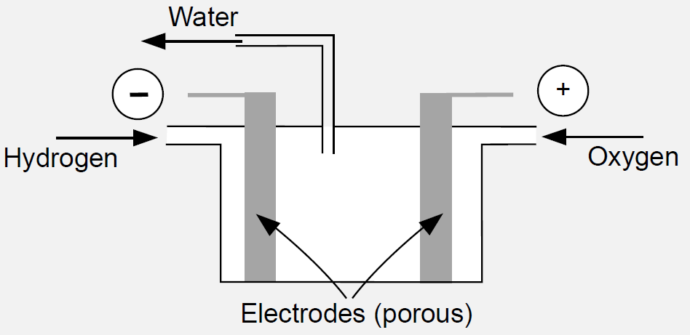
- Hydrogen-oxygen fuel cell
Figures in drawing or graphic format should be inserted in the appropriate place of the text after being drawn in an image editing or graphic program and saved as image file with a resolution of at least 300 dpi.
    - Tables
An example table is given in Table 1. Depending on the purpose of use, other types of tables can also be used
in the text. Caption of the table should be given above the table.
- An example table
Table Head | Table Column Head
Table Head | Table column subhead | Subhead | Subhead
Content | More table copyª | X | Y
.
If a table is wider than a single column it should be placed at the top or bottom of the page (e.g. Table 2). Texts in the table should be written in Times New Romans font and 9 pt. If necessary, the size of the text in the table can be reduced to 7 pt. Equation editor should also be used in the writing of the equations or the variables used in the equations within the table.
All citations to the tables, figures and equations in the text must be expressed as in the template (ambiguous phrases such as “in below figure/table/equation” should not be used). If more than one tables, figures or equations are cited, punctuations of “,” and “-” can be used. Each table, figure or equation must be cited at least once before its appearance in the text.
    - Hyperlinks
Hyperlinks can be used in the paper. Hyperlinks can be utilized as the links (documents, audio, multi-media etc.) that provide more information about the related topic. Font type of a hyperlink must be same as that of the main text but it should be underlined.
    - Page Numbers
Page numbers should not be inserted into the paper. Headers and footers should not be used in the paper. The template should be maintained as it is. Such arrangements are to be made at the ZJEET editorial office.

Table 1. An example table.
Table Head | Table Column Head
Table Head | Table column subhead | Subhead | Subhead | Subhead | Subhead
Content | More table copyª | ABC1 | ABC2 | ABC3 | ABC4
Content | More table copyª | ABC1 | ABC2 | ABC3 | ABC4

  - Citations
Citations in the text should be given using IEEE styles with numbers in square brackets. The list of references should be given at the end of the paper in order of their first appearance in the text. Use individual sets of square brackets for citation numbers that appear together. For instance, use the expression [1], [2], [7] cites the 1st, 2nd and 7th references. Likewise, the expression [3]-[9] cites all the references from 3 to 9. In this context, the section of references should be arranged as given in reference section. In the Section, [1], [2] correspond to peer reviewed journal papers, [3], [4] books, [5] section in book, [6], [7] conference, symposium or congress proceedings, [8] theses/dissertation, [9] report, and [10] internet hyperlinks. A style that is defined in the style gallery of this template by name “Reference” should be used while writing the References section.
More detailed information about writing the references is given in Appendix B.
  - Other spelling rules
- There should not be a space between % sign and number in percentage numbers. While the percentage (%) sign is written after the number in English sections (for example 83%).
- The figure (or the table) and its caption should be placed in the same column or page.
- Avoid combining SI and CGS units, such as current in amperes and magnetic field in oersteds. This often leads to confusion because equations do not balance dimensionally. If you must use mixed units, clearly state the units for each quantity that you use in an equation.
- Do not mix complete spellings and abbreviations of units: “Wb/m²” or “webers per square meter,” not “webers/m².” Spell units when they appear in text: “...a few henries,” not “...a few H.

- CONCLUSION
In the conclusion Section, summarize the main findings, technique applied and the significance of the study. To promote research in the field, it is recommended that the author clearly states the limitations of the study and suggest some further studies. The Editorial Board of ZJEET expresses gratitude to all authors in anticipation, for preparing their papers in conformity with this template.
- ACKNOWLEDGEMENT
Authors can use this section to acknowledge institutions, persons, project grants and others who in one way or the other contribute toward the success of the study. It is optional though. However, this section is only included when preparing the final copy of the manuscript. To ensure blind review compliance, this section should be left blank during the first submission of the manuscript.
REFERENCES
- A. Abdulkarim, S. M. Abdelkadir & D. J. Morrow. “Model for Optimum Design of Stand-Alone Hybrid Renewable Energy Microgrid”, Journal of Fundamental and Applied Sciences, 9(2), 1074 – 1101, 2017.

- Y. Jibril & A.S. Abubakar,” Fault Analysis and Protection of a Microgrid Using Distributed Energy Resources”, African Journal of Renewable and Alternative Energy (AJRAE), Department of Electrical Engineering, Federal University of Technology, Owerri, Nigeria. 1(1), 34 – 40, 2016.

- H. Saadat, Power System Analysis, New York: Mc Graw Hill.
- R. L Haupt, & S. E Haupt. Practical Genetic Algorithms. 2nd ed. New York, USA, Wiley, 2004.
- J. H. Poore, L. Lin, R. Eschbach, & T. Bauer, Automated Statistical Testing for Embedded Systems. Editors: Zander J, Schieferdecker I, Mosterman PJ. Model-Based Testing for Embedded Systems, 111–146, Boca Raton, FL, USA, CRC Press, 2012.
- A. B. Kunya & M. Argin, “Model Predictive Load Frequency Control of Multi-Area Interconnected Power System”, 2nd Annual IEEE-Texas Power and Energy Conference (TPEC), IEEE Conference Publication, College Station, Texas, USA, 1– 6,.February 8th – 9th, 2018,
- G. S. Shehu, A. B. Kunya, I. H. Shanono, & T. Yalcinoz, “A Review of Multilevel Inverter Topology and Control Techniques”, 2nd International Conference on Electrical and Electronics Engineering (ICEEE 2015), Gazi University, Ankara – Turkey, 17 – 22, 28th – 29th April, 2015.
- Y. Jibril, “Design and Implemetation of Polyphase Induction Machine” Department of Electrical Engineering, Ahmadu Bello University, PhD Thesis, 2015.
- Diament P, Lupatkin WL. “V-line Surface-Wave Radiation and Scanning”. Department of Electrical Engineering, Columbia University, New York, USA, Scientific Report, 85, 1991.
- Global wind statistic, Global wind energy council (GWEC), 2015. Available at: http://www.gwec.net/wpcontent/uploads/vip/GWEC.

